Decision Table
- Online Shopping – Free Shipping Eligibilty
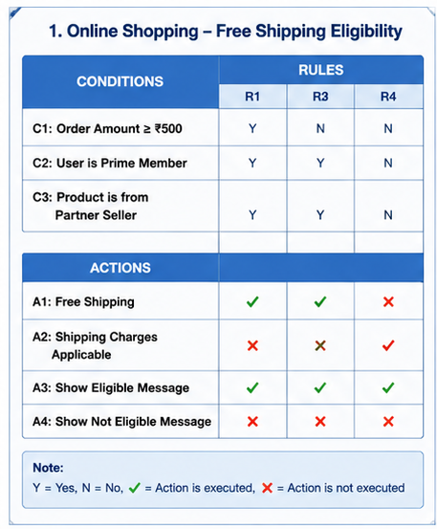
Decision Table Conditions
- C1: Order Amount ≥ ₹500
- C2: Prime Member
- C3: Partner Seller
TC ID | Test Scenario / Inputs | Expected Output | Rule Covered
TC1_01 | Order Amount = ₹700, Prime = Yes, Partner Seller = Yes | Free shipping applied | R1
TC1_02 | Order Amount = ₹700, Prime = Yes, Partner Seller = No | Shipping charges applied | R2
TC1_03 | Order Amount = ₹700, Prime = No, Partner Seller = Yes | Shipping charges applied | R3
TC1_04 | Order Amount = ₹400, Prime = Yes, Partner Seller = Yes | Shipping charges applied | R4
TC1_05 | Order Amount = ₹500, Prime = Yes, Partner Seller = Yes | Free shipping applied | R5
TC1_06 | Order Amount = ₹300, Prime = No, Partner Seller = No | Shipping charges applied | R6

Individual Explanation
TC1_01: Validates the happy path where all required conditions are satisfied. Free shipping should be applied successfully.
TC1_02: Verifies that products sold by non-partner sellers are not eligible for free shipping.
TC1_03: Ensures non-Prime users are charged shipping even when the order value exceeds ₹500.
TC1_04: Confirms that orders below ₹500 are not eligible for free shipping.
TC1_05: Tests the boundary value (₹500) to verify that free shipping starts exactly at the minimum eligible amount.
TC1_06: Verifies that when none of the conditions are satisfied, shipping charges are always applied.

- User Login Validation
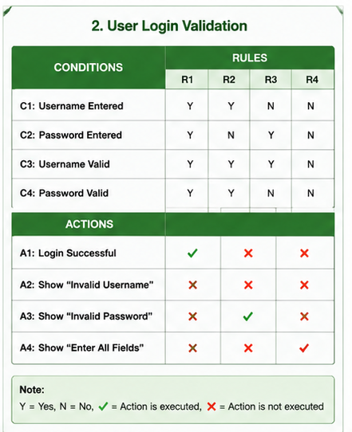

Decision Table Conditions
- C1: Username Valid
- C2: Password Valid
- C3: Account Active

Test Cases Derived from the Table
TC ID | Test Scenario / Inputs | Expected Output | Rule Covered
TC2_01 | Username valid, Password valid, Account Active | Login successful | R1
TC2_02 | Username valid, Password valid, Account Inactive | Account inactive message | R2
TC2_03 | Username valid, Password invalid | Invalid password | R3
TC2_04 | Username valid, Password invalid, Account Inactive | Invalid password displayed | R4
TC2_05 | Username invalid | Invalid username | R5
TC2_06 | Username invalid, Password invalid | Invalid username | R6

Individual Explanation of Each Test Case
TC2_01: Verifies successful login when all credentials are correct.
TC2_02: Ensures inactive accounts cannot access the application.
TC2_03: Confirms invalid passwords are detected correctly.
TC2_04: Verifies password validation occurs before checking account status.
TC2_05: Ensures invalid usernames are rejected immediately.
TC2_06: Confirms username validation has higher priority when multiple inputs are incorrect.

- Bank ATM Cash Withdrawal
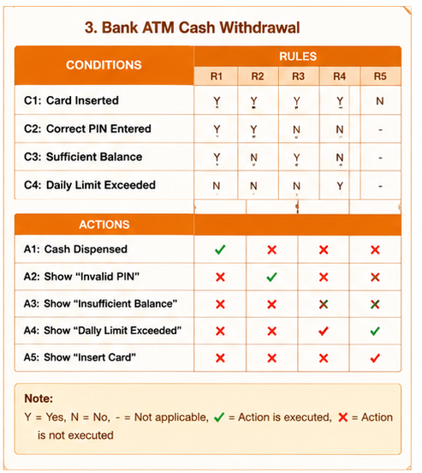
Decision Table Conditions
- C1: Card Inserted
- C2: PIN Correct
- C3: Sufficient Balance
- C4: Daily Limit Exceeded

Test Cases Derived from the Table
TC ID | Test Scenario / Inputs | Expected Output | Rule Covered
TC3_01 | Card inserted, Correct PIN, Balance available, Daily limit not exceeded | Cash dispensed | R1
TC3_02 | Card inserted, Incorrect PIN | Invalid PIN message | R2
TC3_03 | Card inserted, Correct PIN, Insufficient balance | Insufficient balance | R3
TC3_04 | Card inserted, Correct PIN, Daily limit exceeded | Daily limit exceeded message | R4
TC3_05 | No card inserted | Insert card message | R5
TC3_06 | Card inserted, Incorrect PIN, Insufficient balance | Invalid PIN displayed | R6

Individual Explanation of Each Test Case
TC3_01: Validates successful withdrawal when all conditions are satisfied.
TC3_02: Ensures incorrect PIN prevents cash withdrawal.
TC3_03: Verifies the ATM checks account balance before dispensing cash.
TC3_04: Confirms withdrawal is blocked after reaching the daily limit.
TC3_05: Ensures the ATM does not proceed without card insertion.
TC3_06: Confirms PIN validation occurs before balance verification.

- Leave Approval System
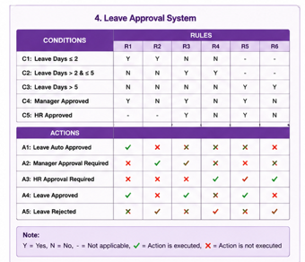
Decision Table Conditions
- C1: Leave ≤ 2 Days
- C2: Manager Approval
- C3: HR Approval

Test Cases Derived from the Table
TC ID | Test Scenario / Inputs | Expected Output | Rule Covered
TC4_01 | Leave = 2 days | Leave approved automatically | R1
TC4_02 | Leave = 4 days, Manager approved | Leave approved | R2
TC4_03 | Leave = 4 days, Manager rejected | Leave pending/rejected | R3
TC4_04 | Leave = 7 days, Manager approved, HR approved | Leave approved | R4
TC4_05 | Leave = 7 days, Manager approved, HR rejected | Leave rejected | R5
TC4_06 | Leave = 7 days, Manager rejected | Leave rejected | R6

Individual Explanation of Each Test Case
TC4_01: Verifies short leaves are approved automatically.
TC4_02: Ensures medium-duration leave requires manager approval.
TC4_03: Confirms leave is not approved without manager authorization.
TC4_04: Verifies long leave requires approvals from both manager and HR.
TC4_05: Ensures HR rejection overrides manager approval.
TC4_06: Confirms long leave is rejected if the manager does not approve.

- E- Commerce Order Cancellation policy
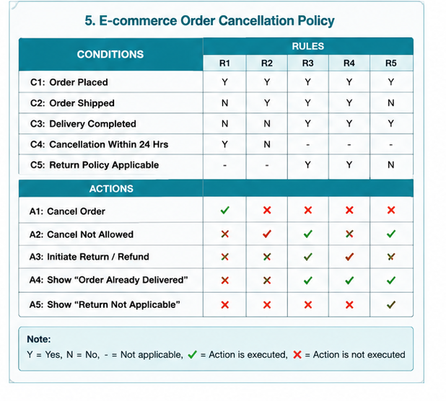
Decision Table Conditions
- C1: Order Placed
- C2: Order Shipped
- C3: Delivery Completed
- C4: Cancellation Within 24 Hours
- C5: Return Policy Applicable

Test Cases Derived from the Table
TC ID | Test Scenario / Inputs | Expected Output | Rule Covered
TC5_01 | Order placed, Within 24 hours | Order cancelled successfully | R1
TC5_02 | Order shipped | Cancellation not allowed | R2
TC5_03 | Delivered, Return policy available | Return initiated | R3
TC5_04 | Delivered, Return policy expired | Return rejected | R4
TC5_05 | Order placed, Cancellation after 24 hours | Cancellation denied | R5
TC5_06 | Order shipped and delivered | Cancellation not permitted | R6

Individual Explanation of Each Test Case
TC5_01: Validates successful cancellation before shipment within the allowed time period.
TC5_02: Confirms shipped orders cannot be cancelled.
TC5_03: Ensures customers can initiate returns when the return policy is valid.
TC5_04: Verifies returns are rejected after the return window expires.
TC5_05: Confirms cancellation requests after 24 hours are denied according to business rules.
TC5_06: Verifies that completed deliveries cannot be cancelled and must follow the return process instead.

